LEGO CONSTRUCTION COMPANY
HEY GUYS, I NEED YOUR HELP IN GETTING SOME PROJECTS DONE BEFORE SUMMER STARTS. CAN YOU GUYS HELP ME?

GARAGE PLAN

- The garage needs to be built on the grey lot pad.

- We need a garage built that has a perimeter of 70 - 80 knobs/studs.

- The garage needs to be in the shape of a Quadrilateral.

- The garage needs to be between 6 – 8 cm in height.

- The owner has asked for some sort of repeating pattern in the garage.

- The Lego manufacturers would like a graph of the number of different colour blocks you used for the entire project.

- The City of Lego would like to know the cost of your garage based on the colour of Lego blocks used.
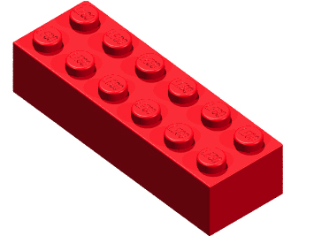
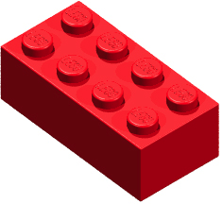

Blue | Black | White | Brown | Red | Green | Grey | Orange | Yellow
WORK ORDER

Colour | Amount | Price | Total
Blue |  | $0.05
Black |  | $0.10
White |  | $0.25
Brown e |  | $0.25
Red |  | $0.25
Green |  | $0.50
Grey |  | $0.50
Orange |  | $1.00
Yellow |  | $2.00

