LEGO CONSTRUCTION COMPANY
HEY GUYS, I NEED YOUR HELP IN DESIGNING A FORT FOR THE KIDS IN THE NEIGHBOURHOOD. CAN YOU CREATE SOMETHING?

FORT/PLAYHOUSE DESIGN

- You need to come up with a design for a neighbourhood fort/playhouse.

- When you have designed the fort you need to build it.

- We are looking to sell your fort/playhouse design package to other neighbourhoods in Lego City - you need to include a step-by-step guide on how you built the fort.

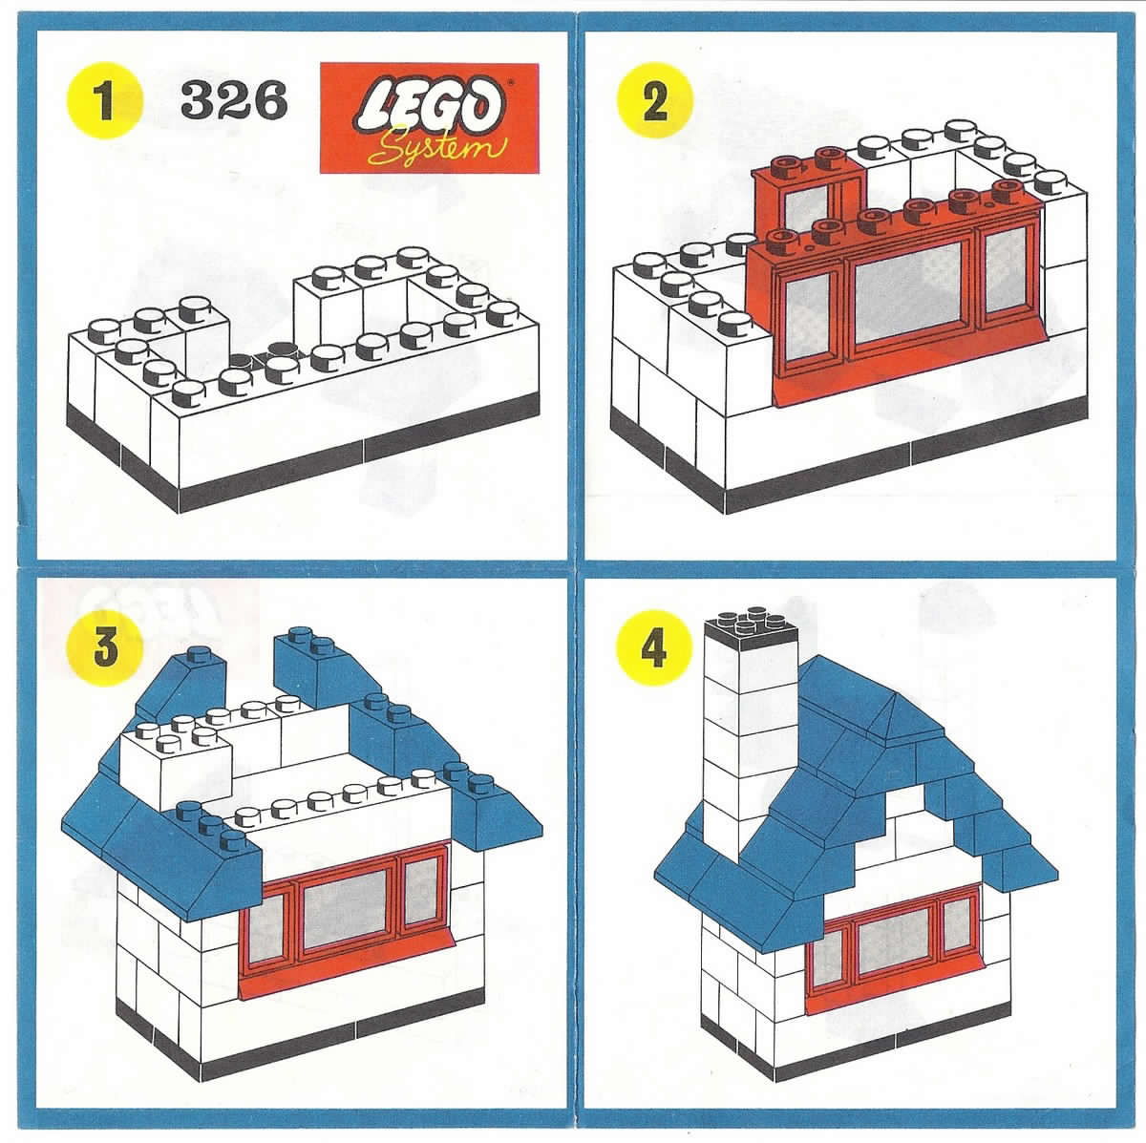
- In order for Emmett to give you the green light to start selling them to other neighbourhoods, the quality control inspector for Lego City (Mr. Williams) must be able to build your fort/playhouse correctly based on the instructions given.
